https://www.iaea.org/newscenter/news/next-generation-nuclear-reactors-iaea-and-gif-call-for-faster-deployment
(дата обращения 29.03.2026)
Next Generation Nuclear Reactors: IAEA and GIF Call for Faster Deployment
The IAEA and the Generation IV International Forum (GIF), an initiative involving 13 countries focused on next generation nuclear power technologies, called for greater efforts to support the early deployment of innovative nuclear reactor systems to address climate change.
17 July 2020
Jeffrey Donovan, IAEA Department of Nuclear Energy
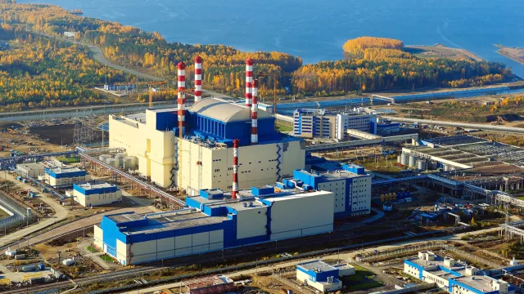
Participants in the 14th GIF-IAEA Interface Meeting, held virtually amid the global pandemic, reviewed progress on the research, design and development of innovative nuclear reactor systems, including in areas such as nuclear safety, proliferation resistance, economics, education and training. (Photo: ROSATOM)
The IAEA and the Generation IV International Forum (GIF), an initiative involving 13 countries focused on next generation nuclear power technologies, called for greater efforts to support the early deployment of innovative nuclear reactor systems to address climate change.
The appeal came during the annual 14th GIF-IAEA Interface Meeting, a gathering of senior IAEA officials as well as GIF members from several nations, the European Commission and the Nuclear Energy Agency of the Organisation for Economic Co-operation and Development, which serves as the GIF technical secretariat. Among other things, participants in last week’s meeting, held virtually amid the global pandemic, reviewed progress on the research, design and development of innovative nuclear reactor systems, including in areas such as nuclear safety, proliferation resistance, economics, education and training.
“Participants called for stepping up action to support faster deployment of these innovative technologies, which can provide significant help as the world transitions to low carbon energy systems,” said Stefano Monti, co-chair of the meeting held on 8 July and head of the IAEA’s Nuclear Power Technology Development Section.
GIF was set up in 2000 to carry out the research and development (R&D) needed to establish the feasibility, safety and performance capabilities of next generation reactor systems, which incorporate major changes in design approaches, fuel, materials or systems configuration in comparison with existing technologies. GIF has selected six reactor technologies for further R&D, including the gas cooled fast reactor, lead cooled fast reactor, molten salt reactor, supercritical water cooled reactor, sodium cooled fast reactor and very high temperature reactor.
Enhancing sustainability of nuclear energy
While broader deployment of innovative reactors may begin after 2030, China is completing the construction of an advanced modular high temperature gas cooled reactor and Russia already operates two sodium cooled fast reactors, the BN-600 and BN-800 at Beloyarsk. Compared with typical reactors, fast reactors produce up to 70 times more energy from their fuel by using ‘fast’ neutrons not slowed by a moderator, greatly enhancing the sustainability of nuclear energy. They can also significantly reduce the volume, toxicity and lifespan of final radioactive waste.
During the meeting, which serves as a venue for reviewing activities of common interest and deciding on key areas of collaboration, participants heard about the IAEA’s activities on innovative reactor technologies, nuclear power economics, outreach and new service by the IAEA’s International Project on Innovative Nuclear Reactors and Fuel Cycles (INPRO) called Analysis Support for Enhanced Nuclear Energy Sustainability (ASENES). The IAEA also presented its activities on advanced nuclear reactor safety, as well as safeguards-by-design, including joint efforts with GIF, to develop a robust definition of proliferation resistance to include in INPRO methodology.
Presentations by GIF members included an analysis of the impact of increasing shares of variable renewable energy sources on the deployment of innovative reactor systems and a discussion of GIF activities on the safety of next generation reactors. Topics of future collaboration such as small modular reactors (SMRs) were also discussed, with GIF members backing a call for greater focus on SMRs.
GIF Chair Hideki Kamide of Japan noted that the integration of nuclear and renewable energy sources, in particular for the production of hydrogen, was a topic of joint interest. Hydrogen produced by low carbon sources can be used in several applications to cut emissions from industry, transport and buildings.
R&D of hydrogen production
The IAEA and GIF agreed to follow up on recommendations made at the meeting, including by focusing R&D on using innovative reactors to produce hydrogen and other activities such as the integration of innovative nuclear systems with other low carbon energy sources.
“This longstanding and ongoing dialogue serves an important purpose: to connect the Agency's activities in support of R&D and innovation in nuclear power with a key international forum in which leading nuclear technology nations collaborate on R&D and discuss major deployment issues,” Mikhail Chudakov, IAEA Deputy Director General and Head of the Department of Nuclear Energy, told participants at the meeting.
The IAEA supports Member States in the development of innovative nuclear energy systems across the whole spectrum of technical areas. It fosters international cooperation on global nuclear energy sustainability and innovation, supports countries in their strategic long range nuclear energy planning, and provides collaborative frameworks for technology development in advanced reactors and the safe use of nuclear energy not only for electricity generation but also for non-electric applications.

